**GRASP KICKSTARTER**

Kickstarter is an American public-benefit corporation based in Brooklyn, New York, that maintains a global crowdfunding platform focused on creativity. The company's stated mission is to "help bring creative projects to life". Kickstarter has reportedly received more than $1.9 billion in pledges from 9.4 million backers to fund 257,000 creative projects, such as films, music, stage shows, comics, journalism, video games, technology and food-related projects.

People who back Kickstarter projects are offered tangible rewards or experiences in exchange for their pledges. This model traces its roots to subscription model of arts patronage, where artists would go directly to their audiences to fund their work.

**PREAMBLE**

Analyse Kickstarter dataset from 2009-2018 and get insights of various categories and its sub-categories of projects based upon each state, goal, pledge, duration of days, and amount invested for them, and then derive the conclusion of which projects are going to be hit in the upcoming years.

**DATASET**

Getting Kickstarter project dataset from Kaggle and start exploring it to get insights.

**State Feature**

Analysing state feature will give some insights about projects.

* Nearly half of the projects failed and 10% of projects got cancelled.
* Only 35% of projects got successful.

**Main Category Feature**

* We can clearly note that failed and successful projects have different frequencies.
* Top projects got successful based on main categories are Music, Film & Video, Games, Publishing and Art.
* Whereas projects based on categories which were failed are Film & Video, Publishing, Technology, Music and Games.
* Projects which were got successful are got failed in the same categories.
* So, there is a significant difference between the categories of successful and failed projects.

**Sub-category Feature**

Upon several sub-categories of projects, here we analyse the top 15 based on its state.

* Like categories, sub-categories also have different frequencies among failed and succdssful projects.
* The above charts clearly depicts the number of projects got success and failure in different categories
* Product design is the most successful as well failed sub-category. Its failure (14113) and success (7962) ratios are nearly half of the total projects.
* 7866 projects were got success in Tabletop games and 6206 were rejected.
* 6673 projects were got success in Shorts whereas 5638 were failed. Compared to top 2 projetcs, shorts projects were failure trend decreasing more.

**Currency Distribution**

Project creation is currently available to individuals in the US, UK, Canada, Australia, New Zealand, the Netherlands, Denmark, Ireland, Norway, Sweden, Germany, France, Spain, Italy, Austria, Belgium, Switzerland, Luxembourg, Hong Kong, Singapore, Mexico, and Japan. By default, the currency displayed on the project is determined by its country of origin.

However, pledges will always be collected in the project's native **currency**, not in a backer's preferred display **currency**. The above char shows most of the creators are from US.

This chart clearly depicts nearly 90% of transactions are in USD (American Dollar), followed by United Kingdom Pound (GBP), Euro, Canadian Dollar and Australian Dollar.

**Backers**

Backers are folks who pledge money to join creators in bringing projects to life. Kickstarter is not a store; **backers** support a creative process. Rewards are a creator's chance to share a piece of their **project** with their **backer** community. Backers that support a project on Kickstarter get an inside look at the creative process, and help that project come to life. They also get to choose from a variety of unique rewards offered by the project creator. Rewards vary from project to project, but often include a copy of what is being produced (CD, DVD, book, etc.) or an experience unique to the project. Backers can also opt to pledge for a project without selecting a reward.

Backers are interested to spend their money in Games followed by Design, Technology, Film & Video, Music and then Publishing.

**Funding Goal, Pledged and Campaign (project) duration**

Every project creator sets their project's funding goal and deadline. If people like the project, they can pledge money to make it happen. If the project succeeds in reaching its funding goal, all backers' credit cards are charged when time expires. Funding on Kickstarter is all-or-nothing. If the project falls short of its funding goal, no one is charged. *Project creator’s raised high funding amount for Film & Video, followed by Technology, Games, Design, Food, Art, Publishing and Music*

But Backers pledged more money than creator’s goal for Games, Design, Technology, and Music. Whereas Film & Video category also got impressed by Backers, this category did not achieve its goal by small amount of difference only. So, Film & Video neither got success nor failed.

**Logarithmic distribution among successful and failed projects in terms of Goal and Pledged**

Using the **log** transformation to make **data** conform to normality. The **log**-transformed **data** follows a normal or near normal distribution and it does remove or reduce skewness.

**Log(goal) Distribution**

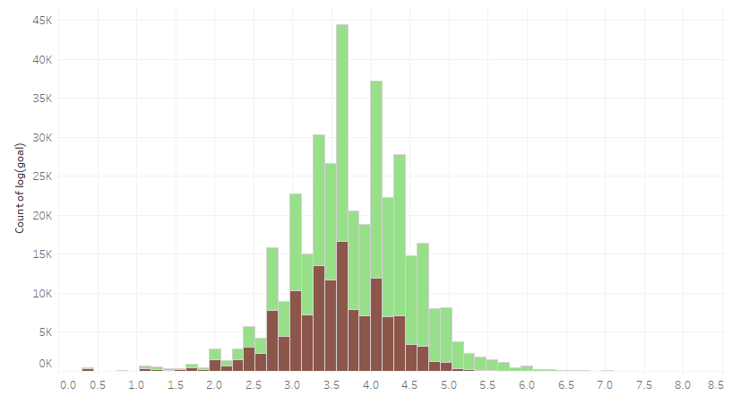This visualizing log data provides insights about successful and failure rate of fund raise by the creators.

Goal which has above 30 k got only minimum successful rate. Project goal that ranges from 10k to 25 k achieved decent success rate.

Even though projects below 10 k are less in number, they got more success rate than all above.

**Log(pledged) Distribution**

**Relationship between project duration and successful distribution**

Here we clearly see that the Top 10 project categories have shorter duration of time. Projects less than 40 days got higher successful rate than those projects had greater than 40 days.

Top categories such as Music and Film & video, games, and publishing were less than 32 days to complete.

There is a **strong** relationship between *duration* and *successful* distribution of campaign.

**Year-wise distribution of Failed and Successful projects**

Analysed from the year 2009 to 2017, successful projects were constantly increasing and maintain a linear trend from 2014 onwards. Whereas failed projects count started tremendous increasing from 2010 and lasts up to 2015. From 2015 onwards we could see the decrement.

**SUMMARY**

**Forecasting trend of 15 main categor**y

The below chart shows the **forecasting trend** of main category from the year **2017-2021** based on the *historic year* from *2009-2016.*

Actual value Forecasted value

**

e

The above line graph clearly depicts the forecasting trend with values. The shaded area in forecasting says that the values may vary from the value that printed up to that area range.

**Top 10 main-category and Top 15 sub-category distribution**

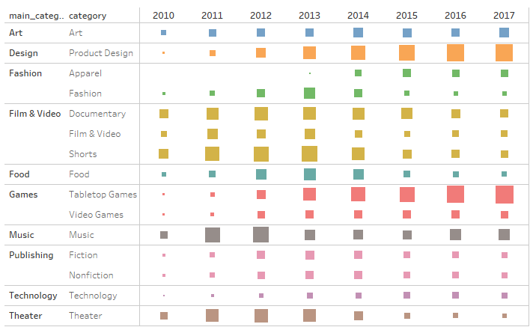

* Projects with **shorter duration** have higher success rates.
* According to that forecasted trend, **Games, Music, Publishing, Design**, and **Art** categories has **high** growing trend in future.
* Technology, Food, and Fashion have considerable amount of growing trend in future.
* **Photography, Theater, Journalism, Dance, Crafts**, and **Comics** have **less** growing trend.
* Film & Video has decreasing trend from 2014. So, we anticipate it will decrease further in future.
* Campaign (project) based on **Game category** like *Tabletop games*, and **Design category** like *product design* are definitely going to be hit in future.